|  |
| --- |
| 新东方在线英语学习 |
| 新概念 1 册 |
| Lesson29-30 |



扫一扫。更多有趣的英语资讯。

# Lesson 29 单词讲解

1. shut：关门

The door is shut. adj. 门是关着的。

Shut the door. v. 关门。

1. bedroom：卧室in the bedroom

untidy：不干净的ang tai di

un- 不, 表示否定clean

easy happy

1. must : 必须

情态动词——情感, 态度

You must go out.

Can you go out please?

1. open：打开

The window is open. adj. 窗户是开着的。

Open the window. v. 打开窗户。

1. air：使空气流通

The air is fresh. 空气清新。Fu ruai shi

Open the window and air the kitchen.

打开窗户, 让厨房通下气。What is the color?什么颜色的？ Color the picture. 给图片 上个色。 I like milk. 我喜欢牛奶。

Milk it. 给奶牛挤奶。

This is my book. 这是我的书。Book a ticket. 预定一张票。There is some water in the glass. 杯子里有水。

Water the flower. 给花浇水。F lai wo

There is some dust .

那有灰尘。

Dust the table.

把桌上的灰尘清扫掉。

1. put：放置,搁

把书放桌上:

Put the book on the table. Put your hand in your pocket. 把手揣衣兜里。

1. clothes：衣服（单复数同形）ke lou si

people\ hair\ fish\ sheep…

1. wardrobe：大衣柜

把外套放在大衣柜里面。

Put your coat in the wardrobe.

1. sweep：清扫si wei yi p

Sweep the floor please.

1. 祈使句
   1. 没有主语
   2. 动词打头

Come in. Go out.

Shut the door. Open the window. Air the room…

1. What must I do?

# Lesson 29 课文讲解

What must I say \ read\ clean…? Where must I go\ live\ stay…?

Who must I meet \ love\ care\ …? which must I like\ take\ find?

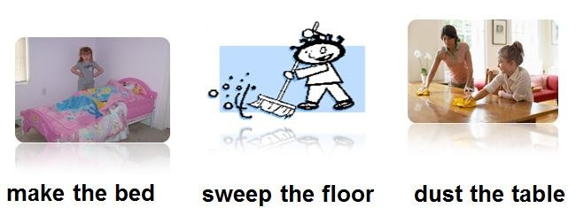

3.

# Lesson 29 语法讲解

1. 祈使句：用来表示命令、请求、建议等；
   1. 表示命令：动词原形+ … Shut the door.
   2. 表示请求：please+ 动词原形+… Please give me it.
   3. 表示建议：Let’s+ 动词原形+… Let’s go, ok?

# Lesson 30 单词句型讲解

1. empty：倒空、使变空

My mind is empty. adj. 我的大脑一片空白。

Empty the bottle please. v. 请把瓶子倒空。

1. read：读、看

看书、看报看杂志 :read a book\ newspaper\ a magazine

1. sharpen：使锋利

adj. + en = v.

sharp + en= 使锋利short + en= 缩短weak + en= 削弱

1. put on & take off
2. turn on & turn off

打开带电的设备

turn on\off the television turn on\off the radio turn on\off the light

turn on\off the tap(水龙头)…

1. 句型：What must I do?

What must I say \ read\ clean…? Where must I go\ live\ stay…?

Who must I meet \ love\ care\ …? which must I like\ take\ find?

Toilet tao ai ao lei te

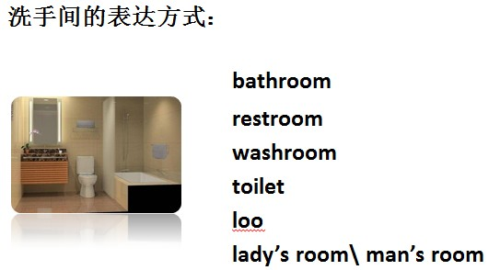

**Lesson 29&30 知识拓展**